**Semester Work 2019-2020**

**Artificial Intelligence-Logical Programming**

**Subject: Implementation of operations with lists**

**Ioannis Venitsanopoulos – Luiz Alousi   
  
  
[ioannisvenitsanopoulos@yahoo.com   
alousilouis@yahoo.gr](mailto:ioannisvenitsanopoulos@yahoo.com alousilouis@yahoo.gr)**

**We open the SWI-Prolog program. Then the following environment opens as in the picture:  
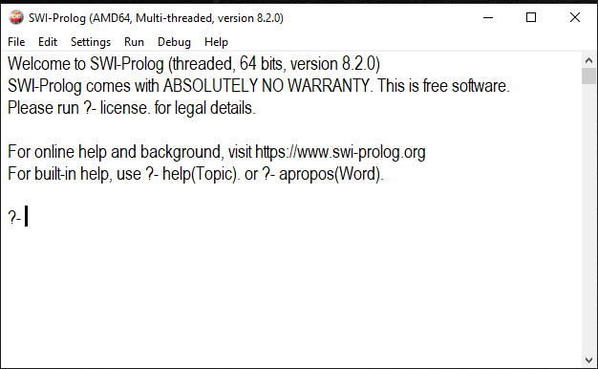**

**Select File-> Consult then a window opens (Browse Files) select the application we have made in Prolog language and with the extension (.pl) then we can run the commands as you will see below to start the application to do some actions and give us results.**

**\*\* Note ** in case the letters are small select Settings-> Font and enlarge the font.**

**The commands we use to run our application in the Prolog environment are the following:**

**To add (+):**

**? -list_sum (First List, Second List, R), write (R).**

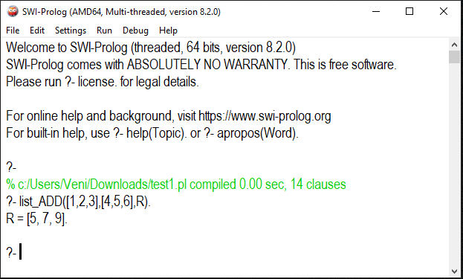

**As we see in the image above it adds the numbers between them lists and gives us the result in a new list**

**R = [5,7,9].**

**To remove (-):**

**? -list_sub (First list, Second list, R), write (R).**

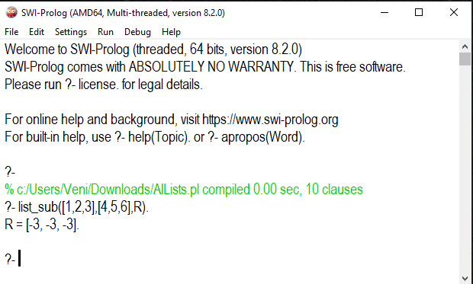

**As we see in the image above, it subtracts the numbers between the lists and gives us the result in a new list R = [-3, -3, -3].**

**For multiply (*):**

**? -list_mul (First List, Second List, R), write (R).**

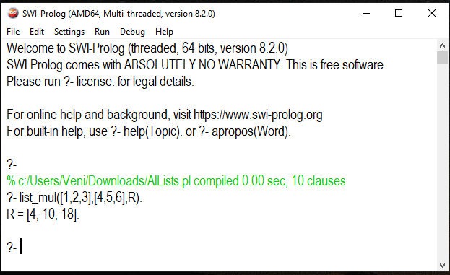

**As we can see in the image above, it multiplies the numbers between the lists and gives us the result in a new list.**

**R = [4,10,18].**

**For division (/):**

**? -list_div (First list, Second list, R), write (R).**

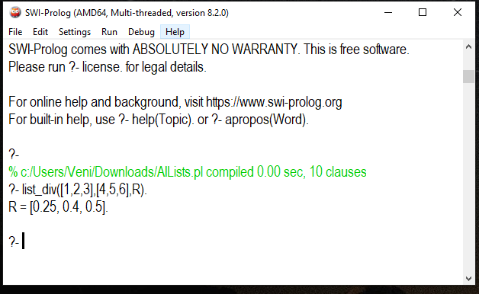

**As we see in the picture above, it divides the numbers between the lists and gives us the result in a new list R = [0.25,0.4,0.5].**

**For Append ("List Gluing"):**

**? - append ([First list], [Second list], X).**

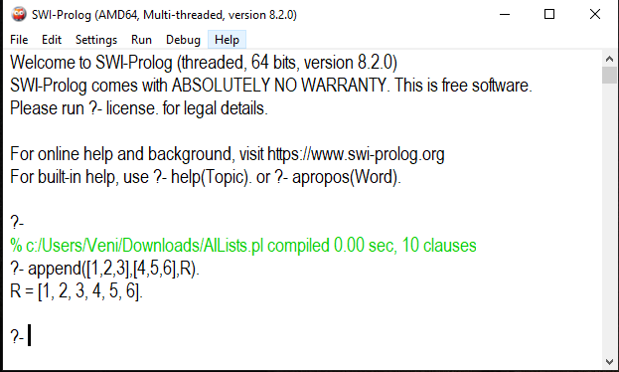

**As we see in the picture above "Sticks the two lists in one" the numbers between the lists and gives us the result in a new list R = [1,2,3,4,5,6].**

**End of work**